2026-27 Key Information

Dear parents and carers

As we start to plan for the new school year, we look forward to bringing the children more opportunities within their new year group. The teaching team are currently planning engaging lessons alongside inspiring visitors and exciting trips and residentials.

Here is some key information that you will need to know for the coming year.

The Ludlow Team

Times of the Day
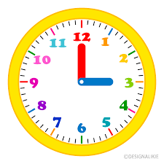
The times of the school day are as follows:
8:40 - 8:55 gates open
8:55 – 9:00 registration
3:25 home time

Parents can come onto the playground to drop their child off and collect them at the end of the school day.
Children should go straight into school when they arrive on the playground. We ask that parents leave the playground swiftly.

Staying Healthy at School

Healthy school dinners are available every day and include meat/ veg/ jacket potato and baguette options. Currently, school meals cost £3.10.

We ask that snacks that are brought into school for breaktime are healthy e.g. a piece of fruit.

Please bring a named bottle of water to keep hydrated during lessons.

We aim to be a nut free school due to pupils with severe allergies. Therefore, we ask you not to send in any food that contains nuts.

Weekly Home Learning

All pupils are expected to complete weekly home learning.

Home learning day is a Friday.
Home learning covers:
1. times tables
2. spelling lists
3. reading

Weekly spellings will be sent home in a spelling booklet. It is important that this is brought back into school every day as it is used for their learning in school.

Teachers will test children on the spellings that they have learnt on a Friday.

Children who regularly complete home learning to a high standard will be rewarded. Teachers will phone home when they are concerned that home learning is frequently not being completed.

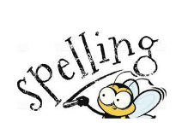




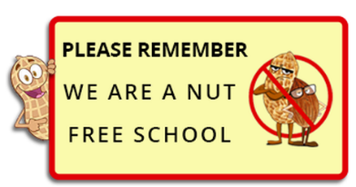

School Uniform
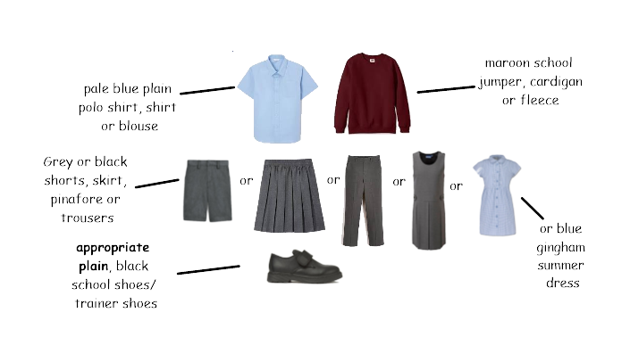

Children must attend school in their school uniform.

School uniform must consist of the above. You can purchase uniform with a logo on but plain uniform without a logo is also acceptable.

Any child who is not in appropriate school uniform will not be allowed on the playground at break and lunchtime.

Skirts / shorts should be no shorter than just above the knee.

Hair, jewellery, and nails

- Jewellery should not be worn apart from one pair of stud earrings.

- Hair should not be brightly coloured. This includes extensions.

- Pupils should not wear fake nails or nail varnish in school.

- Children should not wear fake tattoos.

P.E. Uniform
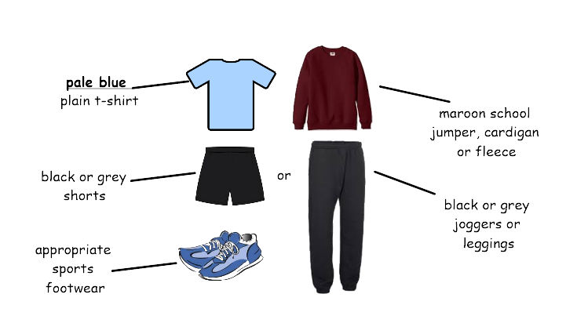

Please label all your child’s uniform.

On P.E. days, children must attend school in their P.E. uniform. No jewellery should be worn for P.E. including stud earnings. If stud earrings cannot be removed, they should be taped up. Long hair should be tied up away from the face for P.E. lessons.

P.E. uniform must consist of the above. Any child who is not in appropriate P.E. uniform will not be allowed on the playground at break and lunchtime.

Communicating with Teachers

Teachers work hard to build positive relationships with parents/ carers. They aim to speak to you on the playground to celebrate individual successes and let you know when things are not going well.
If you have any worries, concerns, or questions, talking to the class teacher on the playground should be your first port of call as it is often easier to support you and resolve any issues face-to-face.
Volunteers / Readers



We continue to welcome support from parents from reading 1:1 with pupils in school, to helping on trips – please email info@ludlowjunior.org.uk for more information.
All parent helpers will need to complete a DBS check to ensure their suitability.

INSET Days
Tuesday 1st September 2026
Wednesday 2nd September 2026
Monday 2nd November 2026
Friday 11th December 2026
Friday 12th February 2027
Friday 25th June 2027

