Dishes and their allergen content Autumn 1 (Week 3 & 6) Meat options

Dishes | 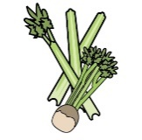 | 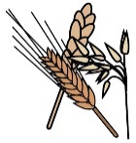 | 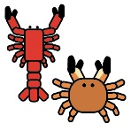 | 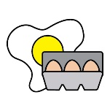 | 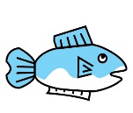 | 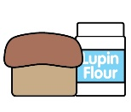 |  |  | 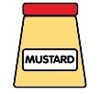 | 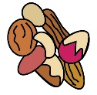 | 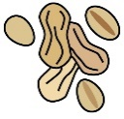 | 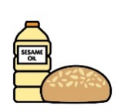 |  | 
 | Celery | Cereals containing gluten* | Crustaceans | Eggs | Fish | Lupin | Milk | Mollusc | Mustard | Nuts† | Peanuts | Sesame seeds | Soya | Sulphur Dioxide
All Day Breakfast – Sausage, Bacon, Hash Brown, Beans & Scrambled Egg |  | x |  | x |  |  | x |  |  |  |  |  | x
Creamy Tuna Pasta Bake, Garlic Bread & Broccoli |  | x |  |  | x |  | x
Pepperoni Pizza, Wedges & Sweetcorn |  | x |  |  |  |  | x
Roast Chicken, Roast Potatoes, Yorkshire Pudding & Mixed Vegetables |  | x |  | x |  |  | x
Tonkatsu Pork, Rice & Green Beans |  | x

Review date: 14/05/26  Allergen substitutes are available for children with dietary restrictions.  Please consult the individual allergen specific menus, for available options.  This can be found on the school website |  |  |  | You can find this template, including more information at www.food.gov.uk/allergy-guidance

Dishes and their allergen content Autumn 1 (Week 3 & 6) - Vegetarian options

Dishes
 | Celery | Cereals containing gluten* | Crustaceans | Eggs | Fish | Lupin | Milk | Mollusc | Mustard | Nuts† | Peanuts | Sesame seeds | Soya | Sulphur Dioxide
Cheese and tomato pizza, potato wedges and sweetcorn |  | x |  |  |  |  | x
Macaroni Cheese, Garlic Bread & Green Beans |  | x |  |  |  |  | x
Quorn Fillet, Roast Potatoes, Yorkshire Pudding & Mixed Vegetables |  | x |  | x |  |  | x
Vegan Sausage Roll, Herby Potatoes & Broccoli |  | x
All Day Vegetarian Breakfast – Two Quorn Sausages, Hash Brown, Baked Beans & Scrambled Egg |  | x |  | x

Review date: 14/05/2026  Allergen substitutes are available for children with dietary restrictions.  Please consult the individual allergen specific menus, for available options.  This can be found on the school website |  |  |  | You can find this template, including more information at www.food.gov.uk/allergy-guidance

Dishes and their allergen content Hot Lighter Bites

Dishes
 | Celery | Cereals containing gluten* | Crustaceans | Eggs | Fish | Lupin | Milk | Mollusc | Mustard | Nuts† | Peanuts | Sesame seeds | Soya | Sulphur Dioxide
Jacket Potato with Beans
Jacket Potato with Cheese |  |  |  |  |  |  | x
Jacket Potato with Tuna Mayonnaise |  |  |  | x | x
Tomato Pasta with Vegetable of the Day |  | x

Review date:14/05/2026  Allergen substitutes are available for children with dietary restrictions.  Please consult the individual allergen specific menus, for available options.  This can be found on the school website |  |  |  | You can find this template, including more information at www.food.gov.uk/allergy-guidance

Dishes and their allergen content Bread Options

Dishes
 | Celery | Cereals containing gluten* | Crustaceans | Eggs | Fish | Lupin | Milk | Mollusc | Mustard | Nuts† | Peanuts | Sesame seeds | Soya | Sulphur Dioxide
Cheese baguette |  | x |  |  |  |  | x
Ham baguette |  | x |  |  |  |  | x

Review date: 14/05/26  Allergen substitutes are available for children with dietary restrictions.  Please consult the individual allergen specific menus, for available options.  This can be found on the school website |  |  |  | You can find this template, including more information at www.food.gov.uk/allergy-guidance

